Database Creation

create database motor_record;

use motor_record;

-- 1. total number of vehicle stolen

select count(*) from stolen_vehicles;

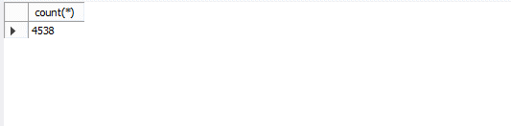

-- 2. Number of region

select count(distinct region) from locations;

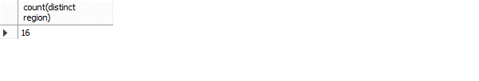

-- Data cleaning and processing

set sql_safe_updates = 0;

alter table stolen_vehicles add new_date_stolen date;

update stolen_vehicles

set new_date_stolen = str_to_date(date_stolen, "%m/%d/%Y");

-- Analysis

-- 1. stolen vehicle days

select distinct dayname(new_date_stolen) as day, count(ï»¿vehicle_id) as numbers from stolen_vehicles

group by day

order by numbers desc;

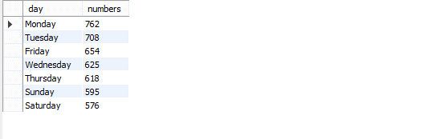

-- 2. types of vehicle based on region

create view data as

(select s.vehicle_type, l.region

from stolen_vehicles s join locations l using (location_id));

select region, vehicle_type, count(vehicle_type),

rank() over ( partition by region order by count(vehicle_type) desc) as numbers

from data

group by region, vehicle_type;

with new_table as

(select region, vehicle_type, count(vehicle_type),

rank() over ( partition by region order by count(vehicle_type) desc) as numbers

from data

group by region, vehicle_type)

select * from new_table where numbers = 1;

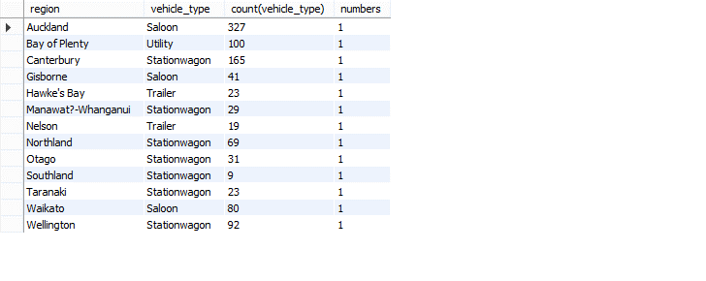

-- 3. age of vehicle based on behicle type

select model_year, vehicle_type, count(vehicle_type) as numbers

from stolen_vehicles

group by 1, 2

having numbers> 40

order by numbers desc

;

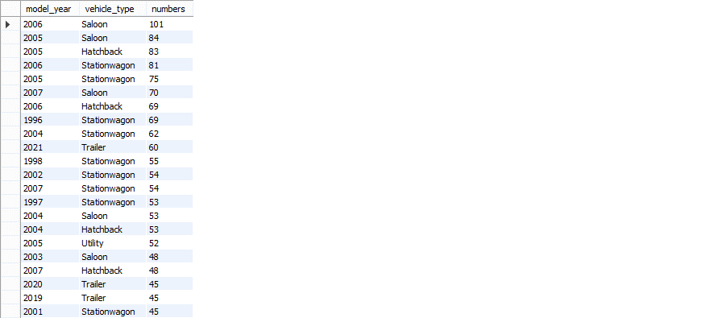

-- 4. region with high and low vehicle stolen, with density

with data as

(select s.vehicle_type, l.region, l.density

from stolen_vehicles s join locations l using (location_id))

select region, density, count(vehicle_type) as numbers

from data

group by region, density

order by numbers desc;

